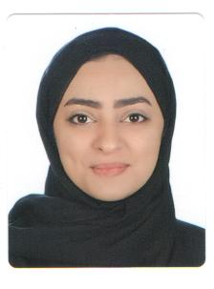
FATEMA EBRAHIM ABDULRASOOL EBRAHIM
VILLA 1492 ROAD 7522 ALJANABIYAH 575, KINGDOM OF BAHRAIN
MOBILE: 38388908
E-MAIL: FATIMAEBRAHIM089@GMAIL.COM

CURRICULUM VITAE
Personal Details:
CPR Number: 890206171
Date of Birth: 27th FEB 1989
Nationality: Bahraini
Marital Status: Married
Qualification & Certificate:
QUALIFICATIONS | INSTITUTE/SCHOOL | FROM | TO
High Secondary Commercial Certificate | Al- Hoora Secondary School | 2004 | 2007
GA Entry Level certificate in ESOL International | VICTORY Training & Development Institute | 25th March 2019 | 2nd May 2019

PERSONAL EXPERIENCE:
- Cleveland Company (From October 2012 To January 2013)
Designation: Debt collector
- The Medical Nutrition Center (From October 2017 until now)
Designation: Secretary
LANGUAGE:
Arabic (Reading, Speaking and Writing)
English (Reading, Speaking and Writing)

SKILLS:
- Dealing with customers.
- Filling, Sending, Receiving and Dealing with e-mails.
- Internet Researches.
- Excellent knowledge of using Microsoft Office –Windows.
- The ability to type in both languages, Arabic and English at very speed.

COMMUNICATION SKILLS:
- Good in communication skill.
- Able to work independently.

PERSONAL SKILLS:
- Learning fast.
- Able to work well with a team.
- Dealing with customer
- Using printing, scanning and fax
- Good in punctuality.

